Lee Pollard High School Information:

Students who are deficient in credits are pretty good candidates for LVP, but what other types of students that you would say are appropriately placed at LVP? Are your courses A-G?
We do get students that suffer from anxiety/depression… that need a smaller school environment. The only glitch to that is if they want to be a-g eligible, we don’t offer any higher level math currently than Finite. We also only offer Environmental and Biology and no World Language. They don’t have to be deficient in credits. With that said, 99.9% of our students will attend community college or trade schools. (The reason they are applying should be noted on the application)
Does LVP offer transportation?
The only transportation we have currently are the busses coming from Eastvale/Norco. If they live within the 4 mile bussing radius they must provide their own transportation.
Contact Transportation Services for more information:
What percentage of students successfully graduate from LVP?
According to the dashboard from last year’s data we had about 73% of the students graduate from all programs (regular/IS/Accelerated Learning Center (ALC)) I’m not sure of the percentage from just the regular program last year.
What kind of help does LVP offer students upon graduation? Is there job placement or community college workshops?
We are currently working on our students completing the FAFSA. We already had a college kick-off night with local community colleges and will be helping them complete their applications. We do offer Work Experience as many of our students do have jobs. We also offer presentations by the military. Basically we offer all the services toward their future as the comprehensives, but not any in depth information on 4 year systems.
Can students return to their home school?
Students can remain and graduate from here or transfer back to the home school if they are caught up on credits (160 by the end of the junior year or 190 by second semester senior year) and must be earning C’s or higher in their coursework. We do not assign homework here unless students fall behind in their coursework. They are expected to work on their portfolios at home and during homeroom. The portfolio work includes all academic core and elective work needed to catch up on credits with the exception of math. Math is offered as portfolio work second semester or for extenuating circumstances.
My approach with students while at the comprehensive was to offer LVP to a struggling student knowing they could either catch up more easily/quickly and adjust to a smaller school environment if needed for any social/emotional problems. I would also inform them that many students end up liking the campus and would choose to graduate from LVP or could transfer back to their home school if caught up on credits.

Is a LVP diploma the same as an SHS diploma?
Often times, students and parents ask if LVP offers the same diploma and we do. Our requirements are the same, it simply has our title on the diploma. Also, there are many situations where the students want to stay, however the parents want them to return to their home school for graduation. My analogy to that is always: if you are winning in a soccer game, would you change your strategy? They must think very carefully if returning second semester senior year as it becomes a “do or die” situation in earning their diploma.
Email received from a former Santiago Student:
Just wanted to email you and tell you thank you for getting me into this school!!! it been my 4th day and I already finished one of my makeup classes and now I got 4 more to go and I can go back to Santiago but I'm planning to not come back and just graduate here
Contact information:
Lee Pollard High School
185 Magnolia Avenue, Corona CA 92879
951-736-3367
Patti Anders, Registrar: panders@cnusd.k12.ca.us

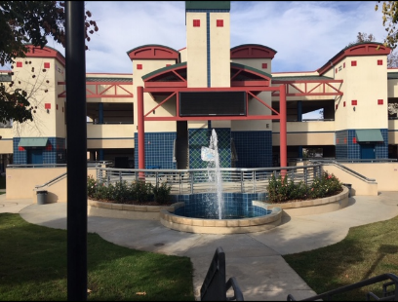
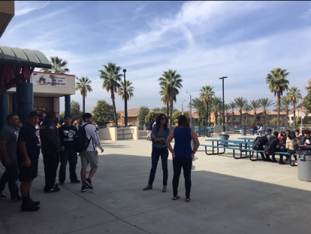
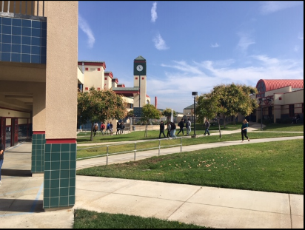
Pics of the campus:

